Laporan Praktikum 3

Nama : Fakhrul Anam

Kelas : 5A

NIM : 18090113

1. Source code

view-form-matakuliah.php 🡪application\views\

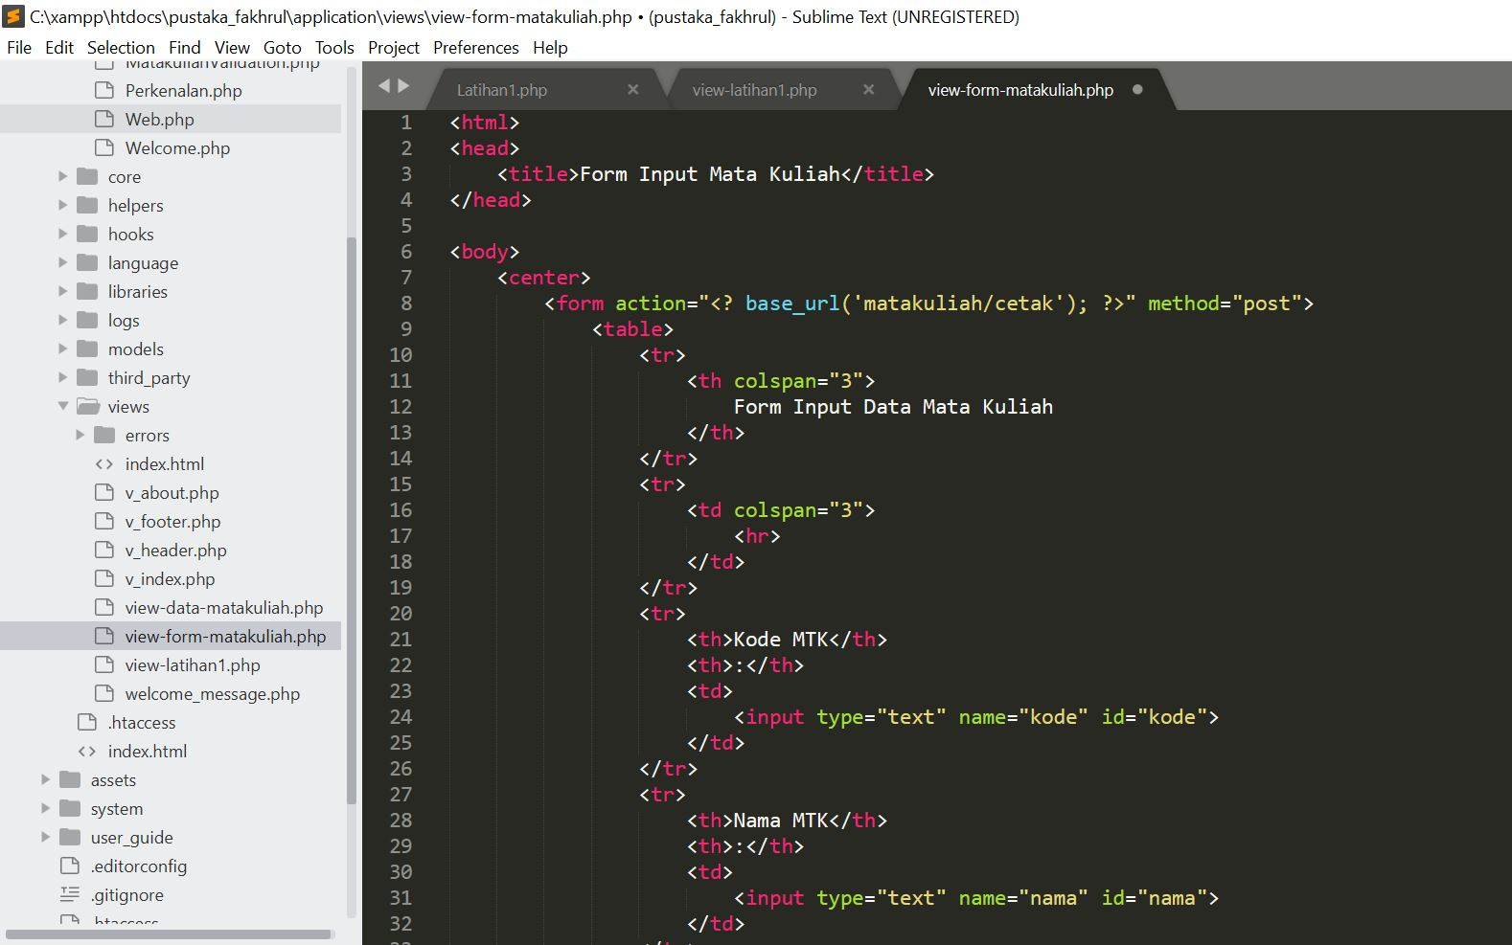

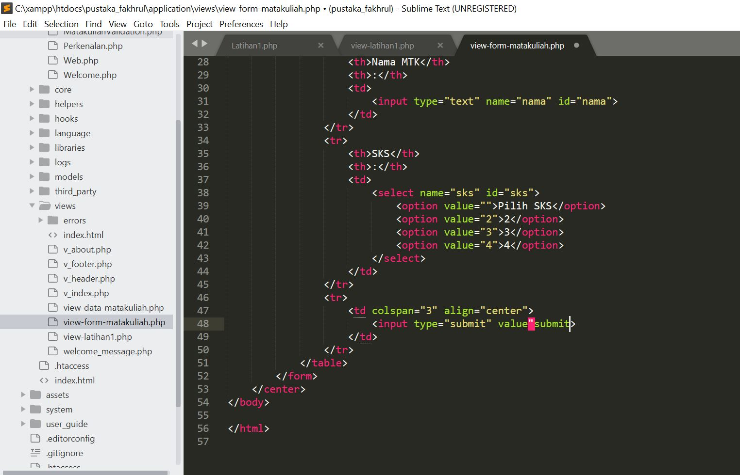

Matakuliah.php 🡪application\controllers\

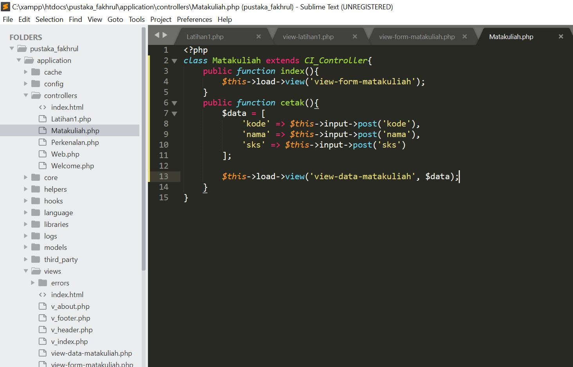

view-data-matakuliah.php 🡪 application\views\

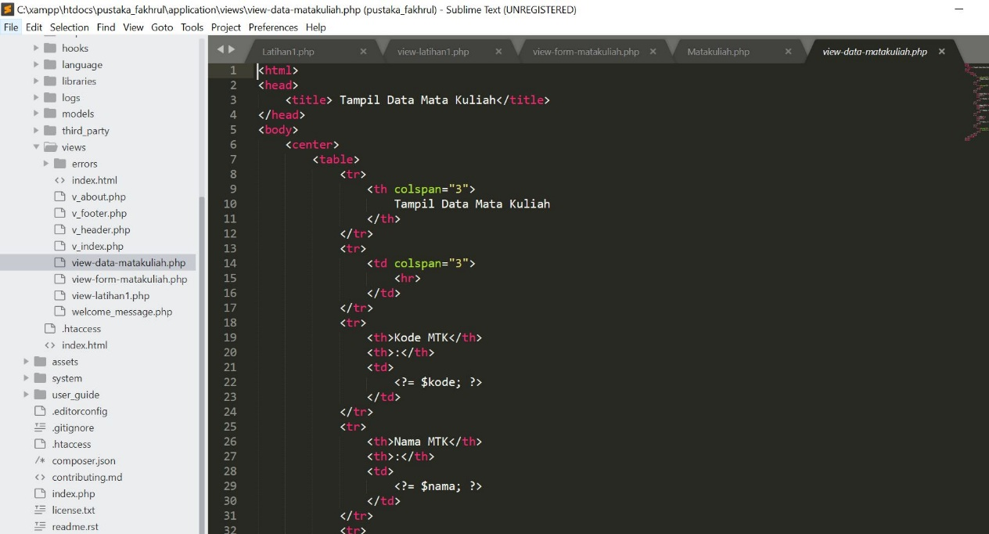

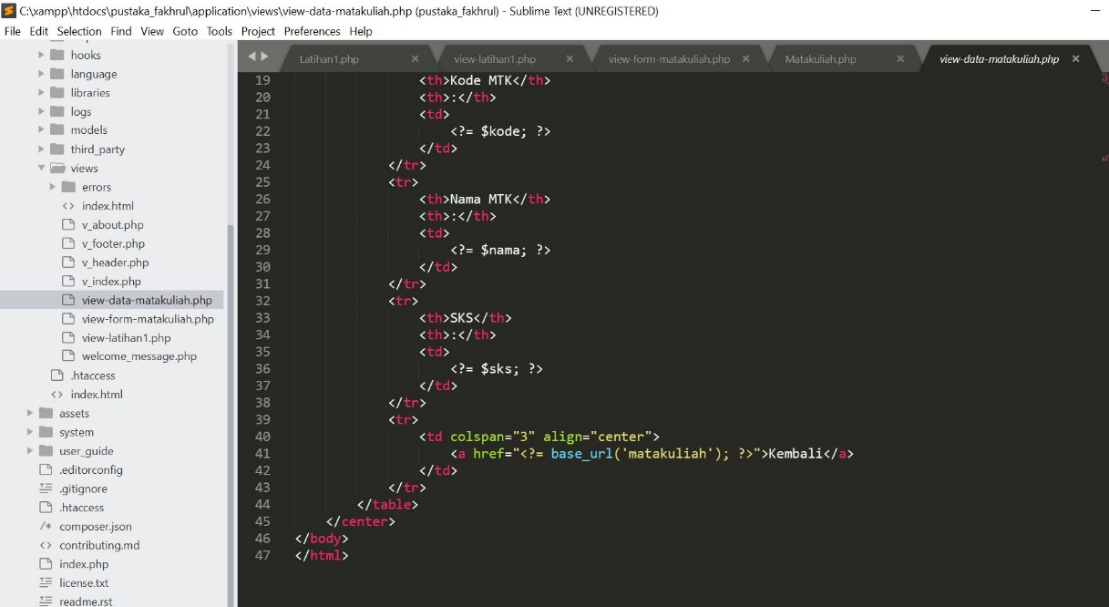

1. Capture Output Program

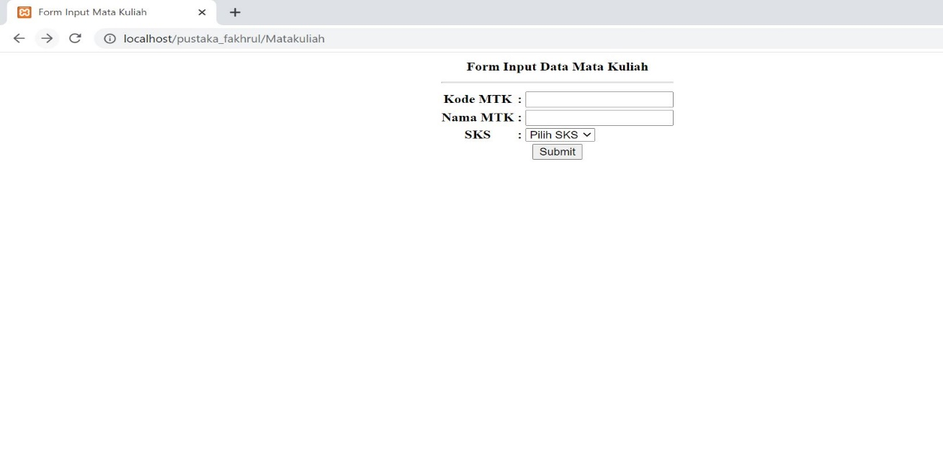

3. URL

<http://localhost/pustaka_fakhrul/Matakuliah>